

MYTH SMASH

**GAME DESIGN DOCUMENT**

Table of Contents

Team Members and Roles: 4

Description: 4

Objective: 4

Game Theme: 5

Game Style: 5

Target Audience: 5

Platform: 5

Tools: 5

Main Features: 5

Game Design: 7

Level/Environment: 7

Environment 7

Obstacles and Traps 7

Objects: 7

Hero 9

Player Actions/States: 9

Customization: 9

Weapons: 9

Properties 10

Enemies: 12

Enemy Actions/States: 12

Customization: 12

Enemy Types: 12

Properties 13

Bosses: 13

Inventory System: 14

UI Game Flow 14

Splash Screen: 14

Start Screen: 15

HUD In-Game Screen 15

Engineering Subsystems: 17

Document History

|  |  |  |  |
| --- | --- | --- | --- |
| Version | Date | Responsible | Description |
| 1.0 | 23 Jan 2014 | Alberto Guerra | Initial GDD Version |
|  |  |  |  |
|  |  |  |  |

MYTH SMASH

# Team Members and Roles:

**Lead Engineer:**  ALBERTO GUERRA

**Hero System:** SABARISH CHANDRAMOULI

**Weapon System:** NICOLAS ABREU

**AI System:** MODDY BAGS

**UI System:** KASHYAP RAJPAL

**Physics System:** ASHISH G MEHTA

# Description:

“Myth Smash” is a 2D side scrolling endless runner with single player mode for iPhone. The inspiration for this game is taken from “Punch Quest”, an AAA iTunes store game. The player runs automatically and advances his position in the level. While he is running, he must tap the screen successively to jump, block, and punch enemies that always try to kill him. Also, the level contains traps and obstacles designed to reduce the health or kill the player. The level contains pickup objects designed to improve the player’s skills and inventory. Thus, the longer the player stays alive the more coins and power-ups he receives. While running, the environment will change smoothly between different sceneries. Also, the player can be customized to change its appearance and main power-up. Also, the player can convert into an animal that is more powerful, fast and has special power-ups. In addition, the combat system included in the game contains QuickTime events where the player has to touch a combination of points on screen to advance the level or to kill a boss. Also, once the player dies, the player have to start the game from the beginning. Then, the player is able to start the game again using the power-ups he collected before. Finally, the level is procedurally generated with branching giving the option to the player to choose easy paths with only a few rewards, or to choose difficult paths with many coins and power-ups to pick up.

# Objective:

The objective of this game is to stay alive and destroy as many enemies as possible to collect coins and power ups.

# Game Theme:

This game depicts an ancient hero that combats mythological Gods and monsters in order to advance in and explore the world.

**If time allows:**

The game will contain three different scenarios with different environments and enemies:

* Nordic ( Vikings ) Environment
* Egyptian Environment
* Indian Environment

# Game Style:

A game described as: 2D Platformer, 8 bit Pixel Art assets (like classic old school games), fast paced, side Scrolling, brawling fighting, and endless procedural generated levels.

# Target Audience:

The target audience of this game is Teenagers and Adults with strong desire of action, fast pace, and gore scenes. The pixel art style of this game is a killer feature targeted to attract players who loved Nintendo and SEGA old school games.

# Platform:

The game is designed to run on iOS platforms. Specifically, it will run on iPhone 5 devices.

# Tools:

* Unity3D 4.3 Windows & Mac (we intend to use only the new 2D features for this game).
* Perforce (source code management).
* Photoshop/Paint.NET.
* Texture Packer.
* NGUI Unity3D Add-on.

# Main Features:

* Side scrolling Endless runner with Fast Pace movement.
* Beat’em brawling combat style for combat with QuickTime events.
* 2D Physics with Rigid bodies and Ragdolls (activated when the enemies are punched).
* Some objects in the level can be destructed to drop coins and power-ups.
* Combat System with power ups, skins, vehicles, and different characters
* AI Enemies (Melee, Range, Flying).
* AI Final Bosses.
* Procedural Level Generation with Level Traps.
* Particles and Visual Effects ( explosions, fire, stars, electricity, …etc).
* Old School Camera System to follow the player and produce pixel art effects.
* Inventory with support for Power-ups/ Upgrades, skins and characters.
* Basic UI (Main Menu, Pause, About, Settings, Intro,…Etc.)
* Smart Audio System to adapt music according to current environment.
* Social Integration (GREE, Facebook and twitter) offering Leaderboard and Achievements.

# Game Design:

## Level/Environment:

Here we describe the features to include according to level and environment generation:

### Environment

* 2D Horizontal Side Scroller with increased difficulty.
* Multi-Phase Procedural level generation:
  + Ground generation
  + Floor, Ceiling, and slopes generation
  + Pipes, and pillars generation
  + Enemies generation
  + Power-ups generation
  + Coins generation
* Multi-layer level generation with parallax dynamic backgrounds. Three Background layers:
  + Background
  + Middleground
  + Foreground
* Smooth transition between different sceneries.
* Special Environment generation when the player starts a boss fighting.
* Different Level zones:
  + Normal gameplay
  + QuickTime Event zone (user has to touch some buttons con continue the level or kill an enemy).
* Generation of Level forks according to difficulty (showing tips to the user about easy/hard paths).

### Obstacles and Traps

* Generation of Ceilings traps that fall:
  + Manually (candelabrum tied by a breakable rope)
  + Automatically (Spikes falling from ceil).
* Generation of Vertical and Horizontal Traps and obstacles on the floor:
  + Fire
  + Blades
  + Spikes
  + Swinging Blades
* Generation of Dynamic Traps that activate/deactivate:
  + Spikes
  + Fire.

### Objects:

* Generation of Destructible objects :
  + Candles ( can drop a power-up or coins )
  + Chests ( can drop a power-up or coins )
  + Ropes holding candles and boxes that can fall and kill enemies or the player.

**If time allows:**

* Level destruction ( create tunnels and holes to allow the player to get loot and gifts)
* Three Different environments: Vikings, Indian, Egyptian.
* Different environment while the player is riding a vehicle/animal.

## Hero

### Player Actions/States:

#### States

* Running ( default state )
* Receive Damage state( When an enemy , object or traps injures the player)
* Death state.
* Jumping state.
* Falling State.
* Immortal State.
* Stopped State
* Blocking State.
* Attacking State.
* Power-up active state.
* Idle state.

#### Actions

* Jump (Left button pressed).
* Punch (Right button pressed).
* Block (Left + Right button pressed).
* Stop moving (Left + Right button pressed).
* Activate Power-up ( Right button pressed, when the player has the power-up bar full)

### Customization:

* Skin Color ( customizable by the user)
* Character Color (when the player activates a power-up or receive damage, the player color changes)
* Body Parts:
* Head ( Helmets, Masks, and Hats)
* Armor

**If time allows:** The user will choose the hero character from three different options:

* + - Indian Hero
    - Egyptian Hero
    - Viking Hero

### Weapons:

#### Melee Attacks:

* + Fist/Spade ( punch close enemies and objects)
  + Uppercut( punches flying enemies or objects above the player)
  + Down Strike “Groudslam” (punch towards ground, throwing the enemy or objects toward the floor).

#### Power-up Attacks :

* Surrounding objects moving in patterns around the player that kills enemies or destroy close objects.
  + Circle Pattern.
  + Spiral Pattern.
* Throw objects according to the current power-up:
  + Arrows.
  + Blades.
  + Lighting bolds.
    - Electricity
    - Plasma
  + Fireball (Burns the enemy for a short period of time). Enemy is attached a fire particle generator.
  + Ice ball (Freezes the enemy for a short period of time). Enemy becomes blue.
  + Customized objects
    - Skull Head.
    - Snake.
    - Dragon.
* Chain Attacks. They hit all the surrounding enemies.
  + Electricity attack.
  + Plasma attack.

#### Special Power-up Attacks:

* Solar beam (objects falling from sky).
  + Fire.
  + Ice.
  + Electricity.
  + Plasma.
* Slow down time (hero keeps the same speed).
* Third Eye (a nuke made of fire that destroys everything).
* Immortality Shield( valid for a few seconds). It changes the players’ color.
* Shrink Enemies (enemies become smaller ).
* Tornado (every enemy becomes ragdoll and move around a vortex).

### Properties

* Health
* Power-up Bar (increases with every enemy killed). Every power-up contains a different target number for this bar; a more powerful power-up requires a longer quantity of enemies to kill.
* Special Power-up Power Bar. It activates after the double of points required to activate the Power-up Bar.
* Current power-up from Inventory.
* Current power-up found in the level ( it only lasts for a few seconds )
* Current special power-up from Inventory
* Current special power-up found in the level ( it only lasts for a few seconds )
* Velocity
* IsInmortal
* If the player finds a power-up in the level, the special/power-up activates immediately for a few seconds.

## Enemies:

### Enemy Actions/States:

#### States

* Walking State
* Idle State
* Running State
* Flying State
* Attacking State
* Blocking State
* Defending State
* Receive Damage state
* Death State.
* Jumping State.
* Falling State.
* Ragdoll State.

#### Actions

* Idle
* Walk
* Run
* Jump
* Fly
* Attack
* Block
* Defend
* Drop Object
* Throw Object
* Drop and Explode Object

### Customization:

* Enemy Color (when the player activates a power-up or receive damage, the enemy color changes)
* Enemy Color according to its difficulty level:
  + Red
  + Blue
  + Green

### Enemy Types:

* Walkers (Just walk toward the player).
* Bombers ( Walk toward the player and when they are close, they explode )
  + Fire bomber.
  + Acid bomber.
  + Plasma bomber.
* Range Attackers ( Attack from distance )
  + Axe/Spade throwers.
  + Bones throwers.
  + Fire throwers.
  + Ice throwers.
  + Acid throwers.
  + Plasma throwers.
* Fast Melee Attackers ( Run fast toward the player and hit him)
  + Minotaur/Bull attack with horns.
* Flying Attackers (Fly in patterns).
  + Linear.
  + Zig-Zag.
  + Front and Back.
* Flying Droppers ( Fly in patterns as above and drop things):
  + Fire.
  + Ice.
  + Acid.
  + Plasma
  + Flyers that throw Powerups/Coins. Those enemies must have a different color, to show that they are going to help the player.
* Melee Attackers (Walk toward the player and try to attack the player with a melee attack):
* Axe/Spade attack.
* Punch (Fist) attack.
* Kick attack.

### Properties

* Health
* Type of Enemy.
* Level/Difficulty
* Velocity.
* Object to Drop.
* Object to Throw.
* Object to Explode ( Bombers ).
* Pattern to use.

## Bosses:

**(If time allows, and to be determined according to development progress )**

Three different bosses with customized AI behavior/movement.

Indian Boss: Ten-headed demon on a flying chariot. Flying in patterns and attack.

Egyptian Boss: Big Crocodile. Show up below the ground and attack

Nordic Boss: Leviathan (Sea Snake). Fly in patterns and attack.

## Inventory System:

* This system saves the accumulated coins that can be used later to buy power-ups.
* This system saves from the player:
  + Power-ups with their upgrades.
  + Customizations to the player character.
    - Head ( Helmets, Masks, and Hats)
    - Armor
* This system allows the user to buy power-ups and customizations from the UI Store.
  + Head ( Helmets, Masks, and Hats)
  + Armor
* This system shows to the user a catalog of available power-ups and customization to buy.
* This system shows to the user a list of upgrades available for every power up that the user owns.

## UI Game Flow

The game will comprise of 4 main screens:

* Splash screen
* Start screen
* Game screen
* Score screen

There will be some optional screens like pause screen, menu screen etc.

The basic flow of the game will be:

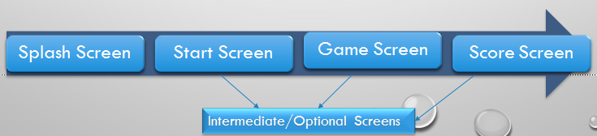

### Splash Screen:

* This screen is starting screen of the game.
* Contains a wallpaper/background/poster.
* Fade away in 3 seconds.
* Provide time for game loading.
* Contains game name.
* Company’s name or studio name may be present on This screen.

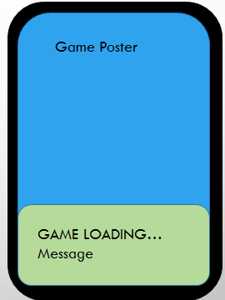

### Start Screen:

* This is a screen just before the game starts.
* Contains various menu options.
* For this game: tapping the screen will launch the game.
* This screen will contain a small animation playing in the background while the user makes up the mind.

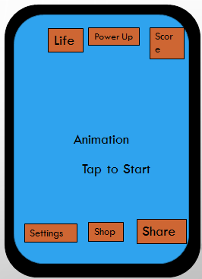

### HUD In-Game Screen

* This screen consists of the main HUD components.
* It consists of background, Levels, enemies etc.

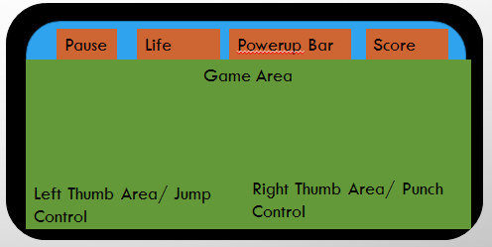

## Engineering Subsystems:

* Game Flow
* Camera Controller
* Physics
* Hero and combat system
* Animation
* AI/Enemies
* Level generation
* Particles/effect
* Inventory/store
* UI/HUD and In-Game UI
* Input controls
* Music/sound
* Social features

